Creating a New Mind to Think about New Ways of Being
Mindfulness is about putting down our juggling balls for a little bit. It’s about embracing the beauty of monotasking. Paying attention in a particular way, on purpose, in the present moment and nonjudgmentally. Mindfulness practice can shrink the brain’s jumpy “fight or flight” center, the amygdale. Accepting things without strongly attaching to them is a major stress-busting technique.
Consistency in mindfulness matters more than all-or-nothing, built-to-fail extremes. It’s a lifelong project. We need to experience emotion that is appropriate in the situation but then not have it bleed over into the next. Just like every time you do a rep is strengthens a muscle so every time you bring your mind back, the stronger it gets, the more focused.
- In exploratory mode we’re open to new experiences and have a desire to learn.
- In exploitatory function, we tend to rely on existing on existing knowledge and lean toward predictable situations.
True Self
Living according to your true self means seeing yourself for who you really are based on your sincere striving to embody the values and achieve the goals you truly believe in.
It includes approaching yourself, your true emotions and needs, from a loving, caring, nurturing perspective that is consistent with how your loving inner guise (Wise Advocate) sees you.
You're Wise Advocate Jesus
The aspect of your attentive mind that knows what you are thinking can see the deceptive brain messages for what they are and where they came from understands how you feel both physically and emotionally and is aware of how destructive and unhealthy your pattern automatic responses have been for you.
The wise advocate wants the best for you it loves and cares for you so it encourages you to value your true self and make decisions in a rational way based on what is in your overall best interest in the long term.
Living with Intent
Intention comes from the soul, from somewhere deep inside us where we get clarity on our heartfelt desire for happiness, acceptance, health and love. Right intention says treat yourself and others with kindness and compassion while living in alignment with you deepest values. Mark 12:28-31 Attention is the rarest and purest form of generosity.
- Incubate: Quite your mind to tap into your deepest intentions.
- Notice: Become mindful of your thoughts and actions, and pay attention to what they tell you about what gives you meaning and sense of purpose. Look for signs that can point you toward your true path. Romans 12:2
- Trust: Have confidence in your inner knowing - and in the messages the God sends you - and allow that knowledge to guide you forward. hebrews12:2 4:14
- Express: Write down your intentions, say them out loud or share them with others to fully embrace them and help you move ahead in your journey.
- Nurture: Be gentle with yourself as you try to find your way. Intention isn’t always a straightforward path, just as life isn’t. Giving yourself opportunities to try and fail is often part of, and even crucial to, the process. “Suffering” and the “kingdom” are inseparable parts of our inheritance in Jesus. In Revelation, “endurance” requires fortitude in view of God’s promises (13:10; 14:12) and during present tribulation (tblipsis in 1:9; 2:3, 9-10; 3:10; 7:14). No one can obtain the kingdom of heaven without first passing through testing. Believers in many parts of the world can identify with the shame and persecution John endured for Christ however most westerners, at the moment, are tested more by materialism than persecution. John’s placing of “the kingdom” between “the tribulation” and “the patient endurance” underlines a recurrent New Testament theme that the patient endurance of tribulation is the way into the kingdom of God. John’s response, (1:9), to his suffering may also be instructive to believers who feel that an easy life is a birthright and prove hostile to those who threaten it.
- Take Action: Once you’ve identified intent, don’t sit and wait for it to magically manifest: instead take the practical steps that can make it become a reality.
The body doesn’t fuel how we live our lives; instead, it is a mirror of how we live our lives. Giving thanks and being thanked is just as important as feeling respected and connected socially. When we’re too busy or distracted, or we’ve unwittingly become a tad self-entitled we disconnect from others and suffer consequences such as loneliness, anger or even a less robust immune system.
Many of us wear our overstimulation as a badge of honor.
People tend to switch activities every three minutes during the course of a typical workday, but it takes significantly longer to get back on the original task.
The fight-or-flight effect in your system churns out the stress chemicals adrenaline, norepinephrine and cortisol, causing your heart to race and blood pressure to increase as oxygen goes to your large muscles. Cortisol helps turn off inflammation in the body, but prolonged stress makes immune cells insensitive to hormone’s regulatory effect. As a result, the inflammatory response that the immune system normally launches to protect the body goes into overdrive. That excess inflammation may lead to anything from the common cold to, in the long run, heart attacks, stroke and autoimmune disorders.
Stress messes with the telomeres, the caps on the ends of our chromosomes that protect DNA as it replicates. Telomeres (like most of us) get shorter with age and sooner with high levels of stress. As telomeres dwindle, genetic material can be damaged, leading to cell death. We model our parents reactions to stress and have a genetic predisposition to be reactive or calm. High cortisol levels from chronic stress break down proteins collagen and elastin, which are responsible for skin elasticity which leads to us, having the Abe Lincoln after the Civil War look.
Addicted to Being a Somebody
Over time, we unconsciously become addicted to our problems, our unfavorable circumstances, or our unhealthy relationships. We keep these situations in our lives to feed our addiction to survival-oriented emotions, so that we can remember who we think we are as a somebody. We just love the rush of energy we get from our troubles!
Moreover, we also associate this emotional high with every person, thing, place, and experience in our outer world that is known and familiar. We become addicted to these elements in our environment as well; we embrace our environment as our identity. Most of us are addicted to the problems and conditions of our lives that produce stress. We limit ourselves to using our senses to define and cultivate emotions, so that we can receive the physiological feedback that reaffirms our own personal addictions.
Creative mode (finding the flow)
In moments of creative activity the dorsolateral prefrontal cortex slows. This part of the brain is for planning and self-monitoring. It is the seat of our attention, focused concentration, awareness, observation, and consciousness. It is where we speculate on possibilities, demonstrate firm intention, make conscious decisions, control impulsive and emotional behaviors, and learn new things.
We have metacognitive capabilities, the power to observe our own thoughts and self, we can decide how we no longer want to be … to think, act, and feel. This ability to self-reflect allows us to scrutinize ourselves and then make a plan to modify our behaviors so we can produce more enlightened or desirable outcomes.
To become familiar with your unconscious states of mind and body takes an act of will, intention, and heightened awareness. If you become more aware, you will become more attentive. If you become more attentive, you will be more conscious. If you grow to be more conscious, you will notice more. If you notice more, you have a greater ability to observe self and others, both inner and outer elements of your reality. Ultimately, the more you observe, the more you awaken from the state of the unconscious mind into conscious awareness.
By beginning to mentally rehearse new ways of being, you start rewiring yourself neurologically to a new mind—and the more you can “re-mind” yourself, the more you’ll change your brain and your life.
Every time you acquire information, you’re adding new synaptic connections that will serve as the raw materials to break the pattern of your brain firing the same way. The more you learn the more ammo you have to unseat the old personality.
The medial prefrontal cortex revs up. This is the part we use to express ourselves. During flow inhibitions fall and creativity rises. Our motion becomes subconscious, (no body, no thing no time), and the release of neurochemicals endorpines, dopamine and serotonin makes us feel good. Finding the sweet spot between challenge and skill is where we find creative flow. You forget about the habit of being you. You lay down your selfish ego and become self-less.
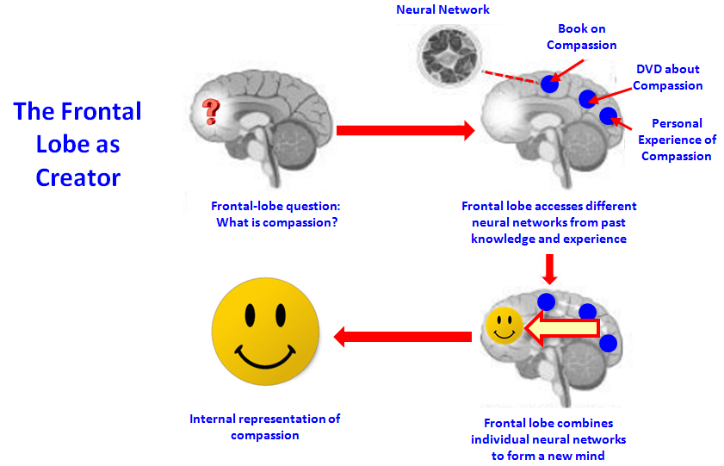
When the frontal lobe is working in creative mode, it looks out over the landscape of the entire brain and gathers all of the brain’s information to create a new mind. If compassion is the new state of being that you want to create, then once you ask yourself what it would be like to be compassionate, the frontal lobe would naturally combine different neural networks together in new ways to create a new model or vision. It might take stored information from books you read, DVDs you saw, personal experiences, and so forth to make the brain work in new ways. Once the new mind is in place, you see a picture, hologram, or vision of what compassion means to you.
When in this creative state, the frontal lobe becomes highly activated and lowers the volume on the circuits in the rest of the brain so that little else is being processed but a single-minded thought. Since the frontal lobe is the executive that mediates the rest of the brain, it can monitor all of the “geography.” So it lowers the volume on the sensory centers (responsible for “feeling” the body), motor centers (responsible for moving the body), association centers (where our identity exists), and the circuits that process time … in order to quiet them all down. With very little neural activity, there is no mind to process sensory input, (remember that mind is the brain in action), no mind to activate movement within the environment and no mind to associate activities with time; resulting we have no body, we have become no thing and we are no time. We are, in that moment, pure consciousness. With the noise shut off in those areas of the brain, the state of creativity is one in which there is no ego or self as we have known it.
As it “lowers the volume” from other areas of the brain, it shuts out distractions. The inner world of thought becomes as real as the outer world of reality. Your thoughts are captured neurologically and branded into your brain’s architecture as an experience. This experience produces an emotion and you begin to feel like that event is actually happening to you in the present. You are now in a new state of being. You could say that in that moment, you are now rewriting the subconscious programs by reconditioning the body to a new mind.
Lose Your Mind, Liberate Your Energy
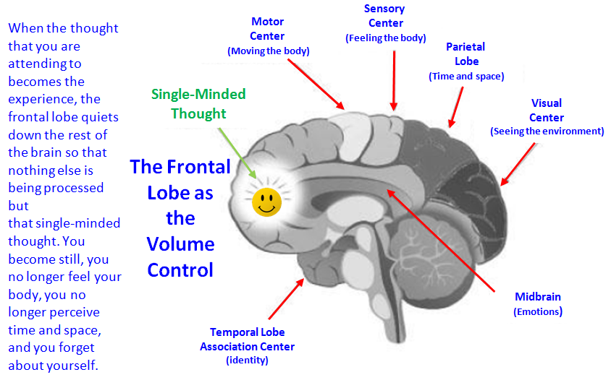
In the act of creation, when we become that nobody or no thing in no time, we no longer create our customary chemical signature, because we are not the same identity; we don’t think and feel in the same way. Those neural networks our survival thinking had wired are turned off, and the personality that was addicted to continually signaling the body to produce stress hormones is gone.
The emotional self that lived in survival mode is no longer functioning. The moment that happens, our former identity, the “state of being” bound by survival-based thinking and feeling, is no more. Since we are no longer “being” the same being the emotional energy that had been bound to the body is now free to move.
The energy that once fed that emotional self now moves up the body from the hormonal centers to the heart area (on its way to the brain) and all of a sudden we feel great, joyful, expanded. We fall in love with our creation. That’s when we experience our natural state of being. Once we stop energizing that emotional self powered by the stress response, we have moved from being selfish to selfless.
With that old energy transmuted into a higher-frequency emotion, the body is liberated from its emotional bondage. We are lifted above the horizon to behold a whole new landscape. No longer perceiving reality through the lenses of those past survival emotions, we see new possibilities. We are now quantum observers of a new destiny. And that release heals the body and frees the mind.
The Two States of the Mind & Body
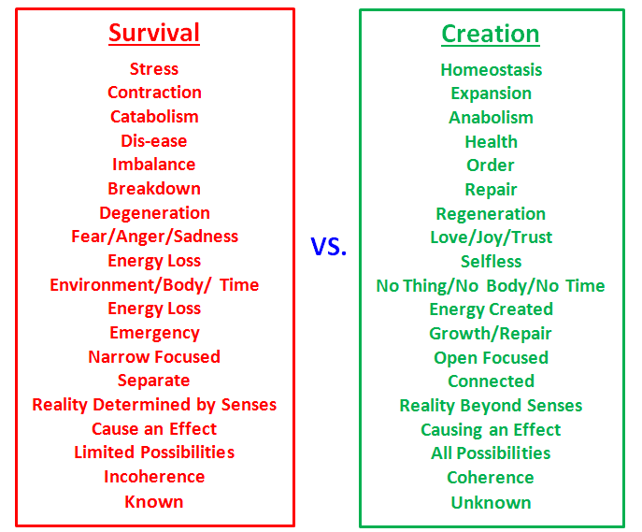
When you’re living in survival, you’re trying to control or force an outcome; that’s what the ego does. When you’re living in the elevated emotion of creation, you feel so lifted that you would never try to analyze how or when a chosen destiny will arrive. You trust that it will happen because you have already experienced it in mind and body, in thought and feeling. You know that it will, because you feel connected to something greater. You are in a state of gratitude because you feel like it’s already happened.
As you linger in this creative state where you are no longer your identity, the nerve cells that once fired together to form that old self are no longer wiring together. That’s when the old personality is being biologically dismantled. Those feelings connected to that identity, which conditioned the body to the same mind, are no longer signaling the same genes in the same ways. And the more you overcome your ego, the more the physical evidence of the old personality is changed. The old you is gone.
God has designed us all to have power over our brain. We are more than our brains, and our Spirits are designed by God to govern our thinking. The Bible clearly assumes that we have control over our thought life and commands us to think about certain things that align with our true identity in Christ Phil. 4:8. The problem is that we live in a culture that enslaves us to a garbage-filled brain given to us by the culture.
We are the movie producers of our brains. Our emotions are caused by the story we tell ourselves (inside) and it is the main determiner of the direction and quality of our life. Society teaches us to live in survival mode inheriting the story the world tells us, often a sad narrative.
Neuroscience shows us that all emotions are associated with the stories and narratives we tell ourselves. They are not directly caused by external events. This is why the same event can cause two people to react completely differently from that same event. It's because of the different stories we tell ourselves. We are constantly telling ourselves stories and running movies in our mind -- it's called thinking. Most of it is unconscious. And we assume these movies are true; but the stories we tell ourselves are NOT necessarily true! Our brain is an organic computer, programmed to the patterns of this world. But the world is fallen, so our programming might be corrupt.
When living in survival mode unfortunate circumstances may make us sad but Paul tells us in Romans 8:35-39, they do not have the power to take our joy away because Jesus endured all the unfortunate circumstances Hebrews 12:1-2 but emerged victorious.
Jesus clearly promises us joy John 15:10-13. Here abide means "to stay, remain, live, dwell, abide; to be in a state that begins and continues, yet may or may not end or stop." Abiding in God's love is to be completely surrounded by it, and to dwell in it, to be filled by it to the point of overflowing. When we abide in his love, we feel joy. This joy is stronger than sin and death and condemnation or failing. Stronger than the devil himself. If our joy is associated with that love, then it can't be taken away. Living in his vast love means external circumstances can't affect us.
In Eph 1:10 He set out a long-range plan, in Col 1:19-20 He will reconcile to himself all things and Rev 21:3-5 He will make everything new.
Paul tells us to take our thoughts captive in 2 Cor 10:4-5. "Arguments" is translated as "a reasoning process". Any thought that contradicts the truth of the love of God, we are to demolish. This mental discipleship is how we engage in spiritual warfare. We have the capability and the responsibility to fight!
Everything depends on how we end our narratives so add Jesus to all the narratives in your brain.
The intensity with which you envision this "extended narrative" is important because Faith is a reality-like vision (hupostasis) of what you hope for or anticipate (elpizo) that creates the feeling that it is so (elegchos) even though you haven't experienced it yet.
Use the immense power of your imagination to truly SEE, creation mode, the extended ending of a narrative story. Catch yourself when you find yourself thinking negative thoughts about a "premature ending" of a story. Catch that and add a minute to it, to include the *real* ending of the story. Even if you suffer from anxiety and die in the narrative you are telling yourself, well, what happens then? Then you get to meet God and bathe in his divine glory! No story's ending can be bad when we know the real and eventual outcome.
In Ephesians 2:6; 1:20-21 we learn that where Jesus sits we sit. He sits in the place of honor, and we are with Him there. So, if Jesus condemns all shame, we can condemn all shame. If Jesus destroyed all shame, we can consider all shamed destroyed. The only question left before us is will we believe it? Will we live experiencing this truth?
Can we really believe that there is a source of truth and identity more competent than our own brain? Will we put God’s voice ahead of our own voice? Romans 12:2 notes that our job is to fight against the patterns of this world by continually making new in our mind what God says is actually true about our identity. God proclaims that we are forgiven and freed, holy and blameless, filled with God’s Spirit, more than a conqueror and set free from the law of sin and death. This needs to be the narrative that we live by in our life and the way we remind our brain what is actually true about us.
Your Brain and Meditation
To summarize meditation is continually reminding yourself who you no longer want to be until this becomes so familiar that you know your old self—the thoughts, behaviors, and emotions connected to the old you that you want to change—to the extent that you unfire and unwire the old mind away and no longer signal the same genes in the same ways. Then as you repeatedly contemplate who you do want to be you fire and wire new levels of mind to which you will emotionally condition the body until they become familiar and second nature.
When you move from the unconscious to the conscious, you begin to close the gap between how you appear and who you are.
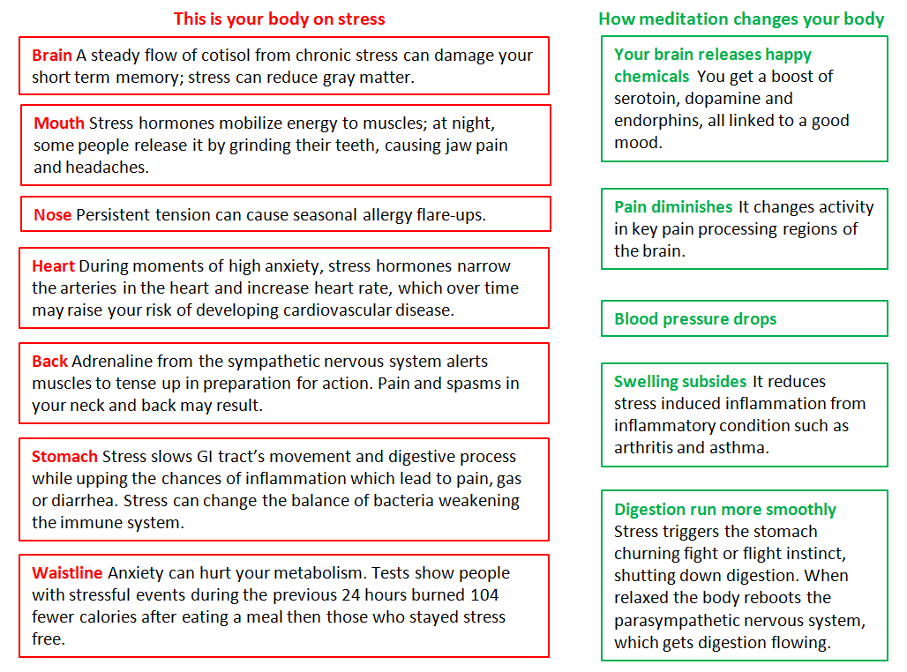
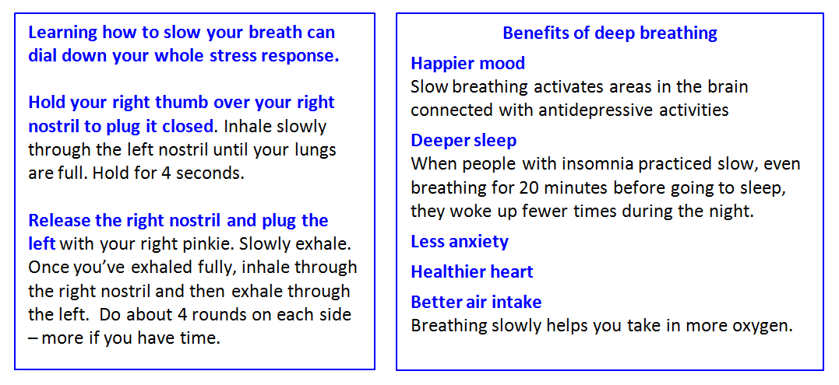
A Five minute meditation
Minute 1 Breathe deeply Rest your hands on the top of your thighs with your legs hip distance apart and your feet flat on the floor. Close your eyes, or leave them open, allowing your gaze to rest, unfocused, a few feet in front of you. Shutting your eyes helps you focus on the inner working of your body, while leaving them open strengthens your ability to stay serene amid external distractions. Observe how your feet feel on the floor: they may seem tingly, or you may sense the hardness of the floor against your toes. Now deepen your breathing (either through the nose, the mouth or both, whichever comes naturally), inhaling for a count of four and exhaling for a count of six.
Minute 2 Find your natural pace Stop counting and allow your breathing to fall into an easy rhythm. Pay attention to what your breaths feel like – not overly deep or shallow – and compare that with your usual cadence. (Most people tend to take short, weak breathes throughout the day, which deprives the blood of oxygen and, in turn, can lower energy levels.) Tune in to the rising and falling sensation in your body. You should experience it from your belly to your shoulders.
Minute 3 Stay focused Continue to be aware of your breathing. If random thoughts (shopping lists, work deadlines) pop into your head, don’t push them out or linger over them. Image each one as a harmless floating cloud. This helps you acknowledge your worries without responding to them emotionally. It the thought doesn’t drift away, jot it down and return to the meditation.
Minute 4 Relax Release your focus on your breathing and simply sit. Remind yourself that there is nothing to do, fix or change.
Minute 5 Give thanks Think about something you are grateful for, such as spending time with friends or having the change to meditate. Then gradually transition your thoughts to show you physically feel: the relaxed state of your muscles and the steadiness of your heart beat. Open your eyes, (if you had them closed), stand up and tackle the rest of your day calm, cool and collected.

The Art of Listening Well
James 1:19
My dear brothers and sisters, take note of this: Everyone should be quick to listen, slow to speak and slow to become angry,
“Good listening starts with this scandalous premise that his conversation is not about you.”
-Adam S. McHugh
“He who can no longer listen to his brother will soon be no longer listening to God; he will be doing nothing but prattle in the presence of God too. This is the beginning of the death of the spiritual life… Anyone who thinks that his time is too valuable to spend keeping quiet will eventually have no time for God and his brother, but only for himself and for his own follies.”
-Dietrich Bonheoffer
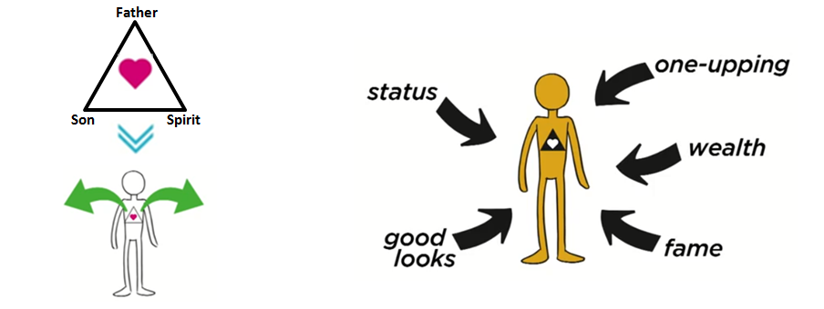
1. Our severed connection with God
- Over 100 times in scripture God tells His people that they are not listening. We need to be listening to the right voice first if we are going to be able to connect to others rightly.
- Prayer without listening to God is missing something vital. Prayer requires genuine relationship- both talking and listening.
2. Assumptions
- The opposite of listening is waiting to speak. When we bring our assumption about other people without taking time to hear them, we are more interested in labeling them then knowing them.
- Resolve to know nothing about people you don’t know other than that Christ died for them.
3. Cultural Validation
- The current culture of America gives attention and power to those who speak, not those who listen.
In 1 Kings 3:5-9 in a dream, God offers Solomon anything he wants. Solomon’s response is, “give your servant a discerning heart.” Discerning heart in Hebrew conveys a listening core. It is later in Solomon’s life we learn that he loses this ability to discern and truly listen and this ends up having massive implications for his son’s reign and the history of Israel.
Lessons for affective listening:
1. Get all of your life from Christ
- We need to practice a rhythm of life where we take space and time to hear from God. This means learning to let go of control and listen for God to speak.
2. Listen with your whole heart
- Pay attention to non-verbal communication, it conveys more than what we say
- Find someone that you trust who you can ask, “how do you experience me as a listener?”
3. Practice Listening skills
- Get curious!
- Reflect on how Jesus asks questions and listens.
- Take time to reflect.
Remember that we fail people when we try to heal them before hearing them.

